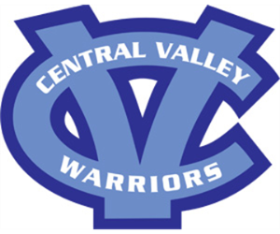
CENTRAL VALLEY HS SOFTBALL BOOSTER CLUB
&
CENTRAL VALLEY GIRLS YOUTH SOFTBALL

Friends of CV HS Softball Booster Club and CV Girls Youth Softball,
Our organizations have come together to host the 4th Annual St. Patrick’s Day Wing Bash on Saturday, March 16, 2024. This event is the main fundraiser each year for our organizations which rely 100% on fundraising to operate. An important part of the success of our event is the Chinese Auction where we sell chances to win baskets of items donated by individuals and businesses within our community.
We are currently seeking donations for this year’s auction. All auction items are announced at the event and presented with the name of the person or business they were donated by. It is through the generosity of the community that helps keep our High School Booster Club and Youth sports programs operating. The High School budget only stretches so far, and these events help provide our girls with the extras that make the season more enjoyable.
If you are interested in donating, please contact one of the following event coordinators or email us at cvsoftballbooster@gmail.com:
Tracy Strickland (724) 462-4523
Nadine Skrlac (724) 601-3674
Janette Householder (724) 417-6301
Thank you for your consideration in making our Wing Bash a success!
****Central Valley Girls Youth Softball: This organization is a non-profit 501©3 organization. Your donation is tax-deductible. Federal Tax ID # 92-1387248

